Assessment form for planning a PEEP (Non-residential)

ASSESSMENT FOR PLANNING EMERGENCY EVACUATION FROM LOUGHBOROUGH UNIVERSITY PREMISES OF PEOPLE WITH RESTRICTED MOBILITY OR SENSORY DISABILITIES

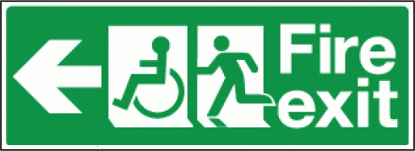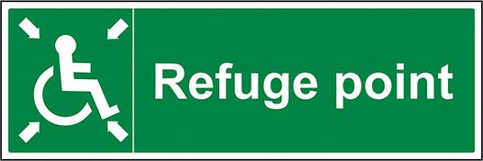

This document is designed to assist departments across Loughborough University in assessing the means of escape and safe egress for disabled people in case of an emergency evacuation of a building.

To assist with evacuations, persons should familiarise themselves with the General Emergency Evacuation Plans for buildings across Loughborough University. These can be found at the link below. It is also advised that persons familiarise themselves with the buildings upon their initial visit.

https://www.lboro.ac.uk/services/health-safety/topics/fire/genericemergencyevacuationplan/

Loughborough University has various provisions in place across its buildings to aid occupants requiring assistance when evacuating a building in emergency. These should be considered when preparing a PEEPs and include but are not limited to the use of Deaf Alerters, Visual Audio Devices (VADs), refuge areas (including Emergency Voice Communication Systems (EVCS)) communicating directly with security, Evacuation Lifts and Evacuation Chairs.
1. The Person

Name of disabled person*:

Hearing impairment:

Can you hear the fire alarm in normal circumstances?

Yes No

If you have difficulty in hearing the alarm, would a visual indicator assist?

Yes No Not Applicable

Is there, to your knowledge, any special or purpose designed hearing system or device available that might assist you in hearing the fire alarm more clearly?

Yes No Not Applicable

Details:

Would your response to the fire alarm being activated, be helped by an ‘assistant(s)’ who could provide support in the fire evacuation procedure?

Yes No Not Applicable

Is there another measure that would assist?

Yes No Not Applicable

Details:

Visual impairment:

Do you have a visual impairment, which would have an impact on your leaving the building unassisted?

Yes No

Details:

Do you require an aid to help you move around the building for example: a cane, a guide dog or other equipment?

Yes No Not applicable

Details:

How long does it take you to leave the building in normal circumstances from your place of work, or residence unaided?

Time in minutes:

Do you think the speed at which you are able to leave the building, may have the potential to holdup other people leaving the building in corridors and stairways, or that they may cause you injury as they pass you more quickly?

Yes No Not applicable

Would tactile signage or floor surface information be of assistance to you?

Yes No Not applicable

Details:

Are there any other problems you wish to highlight or solutions / measures that might assist?

Details:

Mobility impairment:

Can you move to a place of safety without assistance?

Yes No

If no, do you require help from an assistant to leave the building?

Yes No Not applicable

Do you need or use a wheelchair?

Yes No Not applicable

Is the wheelchair required for all circumstances (Yes) or (No) (i.e. can it be dispensed with for short periods?)

Yes No Not applicable

Is the wheelchair a standard size or an electronically powered type with wider dimensions?

Normal Electrical Width:

How long does it take you to leave the building in normal circumstances, unaided?

Time in minutes:

Can you use an evacuation chair if required and would it help?

Yes No Not applicable

Has a carer or a member of staff and deputy been assigned to assist you?

Yes No Not applicable

Name(s) Details:

Details of any other problems / observations / or solutions?

General information

Would you find it acceptable to use a fire refuge, if required?

Yes No Not applicable

Might the measures needed for you to escape from the building in an emergency adversely affect the safe escape of other occupants?

Yes No Not applicable

If yes, why/how:

Details:

Do you think that any special staff training is required to give you the assistance that you would need in an emergency?

Yes No Not applicable

If answered “yes” above, what training would assist, and would specialist-training providers be needed to give this training?

Details:

Notes:

2. The Building’s Physical Environment, Work and Study Areas
(To be completed with the assistance of the person named in Part 1)

Building design and function have an impact on how emergency evacuation is achieved by staff and students. This part of the assessment will help to collect the data necessary to assess the likely physical problems involved in escape and help identify the physical measures that need to be taken to address such problems.

Building name(s)/number(s):

Address:

Department(s):

Number of floors used by the disabled / incapacitated person on a regular basis:

Is the directional and instructional signage adequate and relevant?

Yes No

Details:

Number of staircases:

Details:

Number of lifts and their uses (passengers or goods):

Number and location of problem fire doors, (doors with self-closing devices), that causes significant problems to the person to open and go through independently: Details:

Details of the number and location of exits, access ramps and internal steps, which prove a significant problem to the disabled person:

Other problems identified:

Details:

3. Action Required

Action:
HoS/HoD/HoPS

Responsible person within school to provide disabled person with a copy of their PEEP and ensure that School fire marshals are informed if necessary.

Further action incl. that of disabled person to be recorded here

Personal Emergency Evacuation Plan (Peep) – Summary
(A summary of discussions, management procedures and practical assistance resulting from the assessment for planning emergency evacuation from Loughborough University premises of people with restricted mobility or sensory disabilities).

Name of person being assessed:
Member of staff or student:
Department:
Contact details:
Departmental contacts:  HoS/HoD/HoPS  Contact Number  Email address | @lboro.ac.uk
Date

Summary:
Consideration should be given to the following where appropriate:

Disabled person’s* actions

Sub-warden/Fire Marshal

On arrival of the Fire and Rescue Service (FRS)

Tutorials and lectures in academic buildings
Disabled person has a responsibility to ensure they make themselves aware of the fire evacuation route(s) of all the buildings they attend. They should use the link at the top of this page to look over the GEEPs and have also been advised that they familiarise themselves with buildings upon their initial visit.

In the event of a fire alarm signal in any academic building they shall:

Further comments to note following discussions with disabled person*

*Replace disabled person for their name

